Perfrom PGI

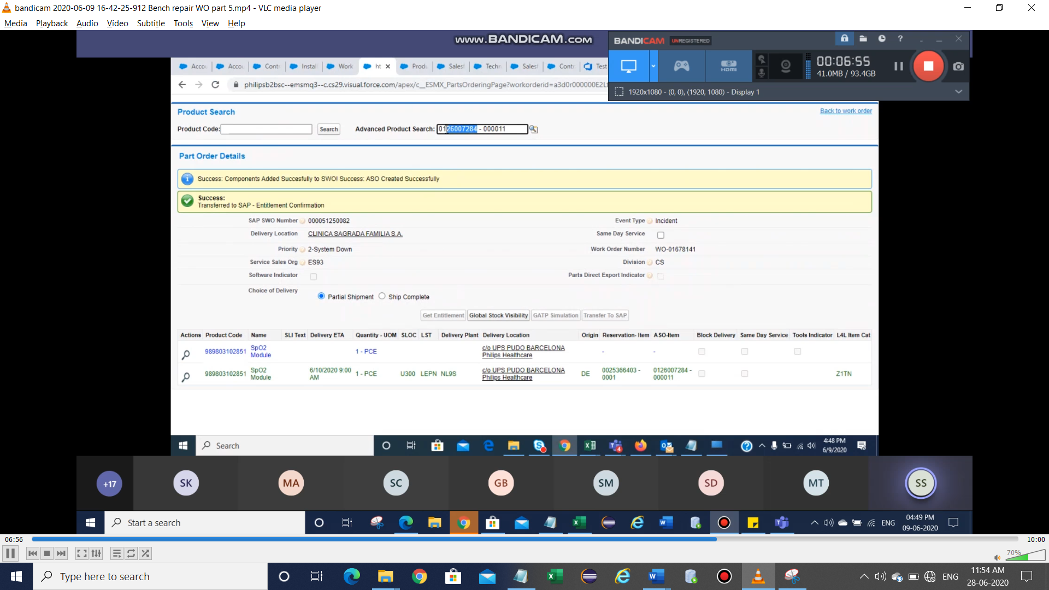

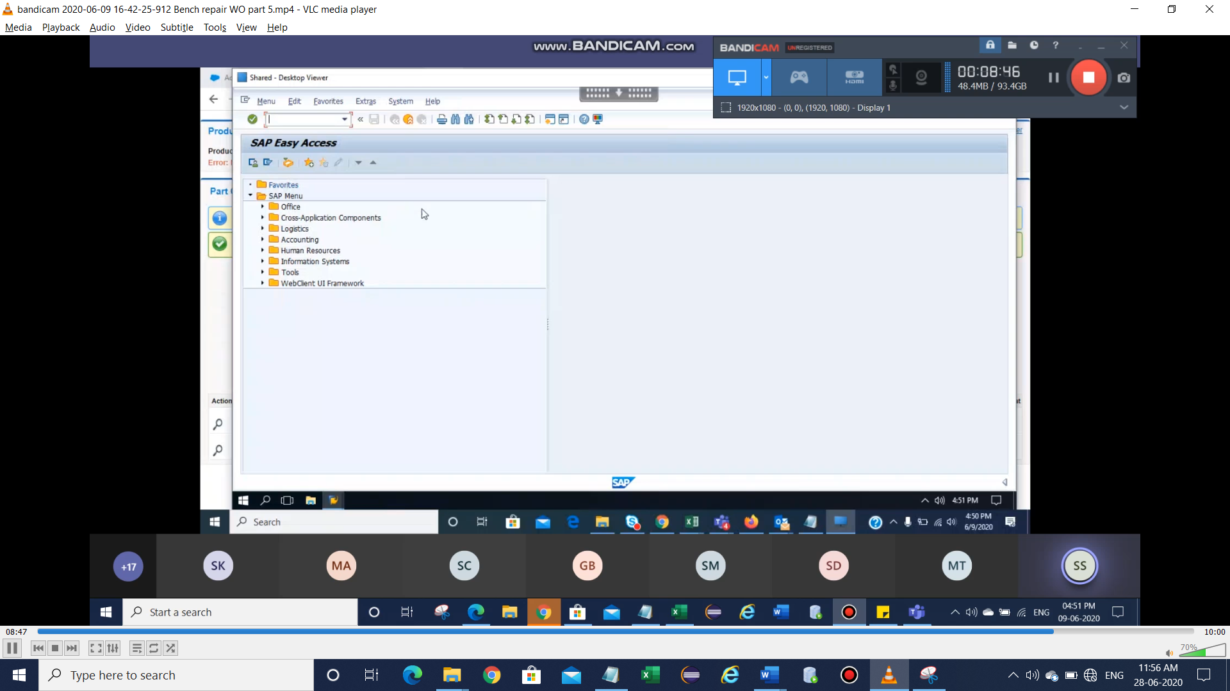

Provide Va03

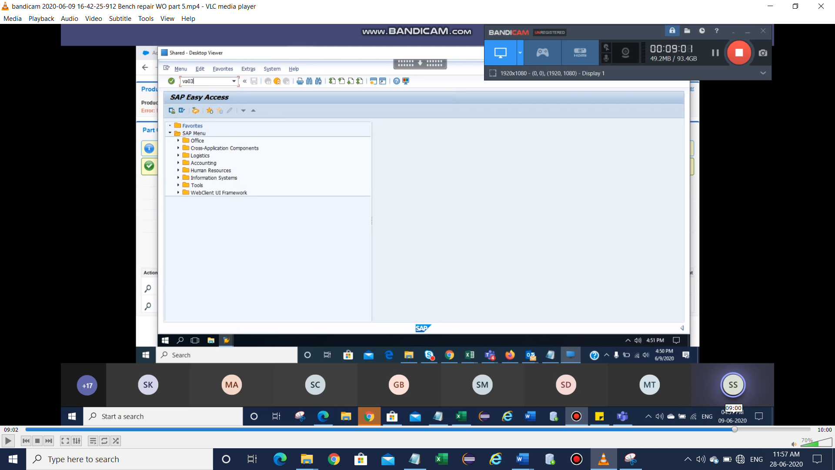

Provide ASO number and press enter

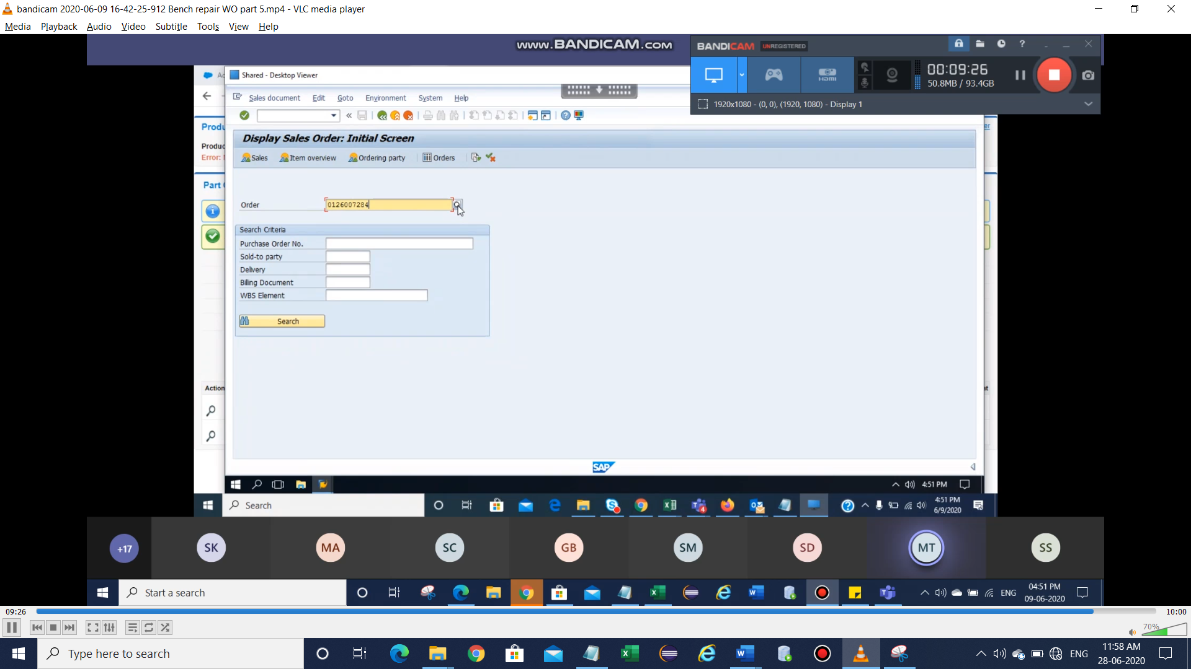

Select the line based on ASO number, in this case , row 11.

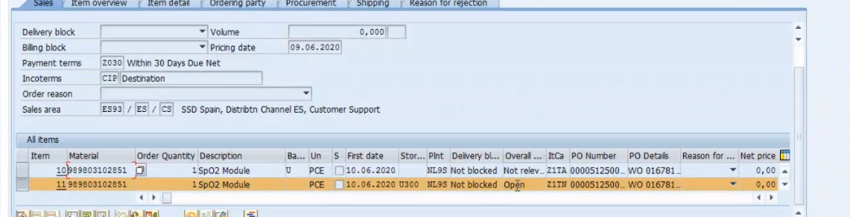

Click on sales document & click on deliver as show below

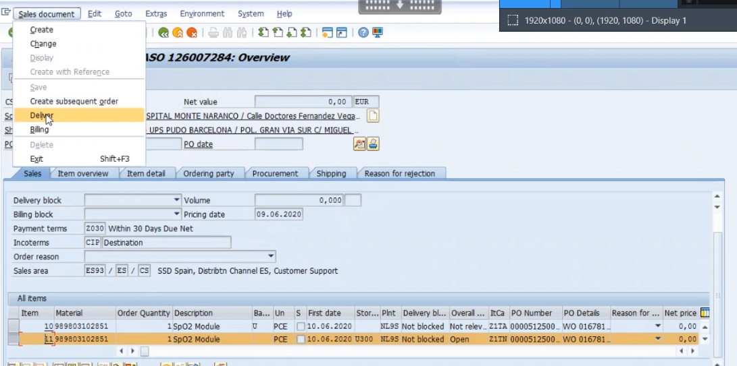

Select the available row and click on picking tap

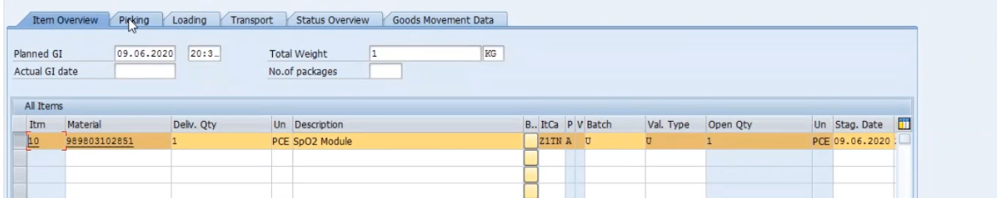

Give the pick quantity value as delivered quantity value.

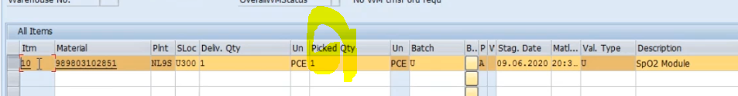

Select the row and click on pack

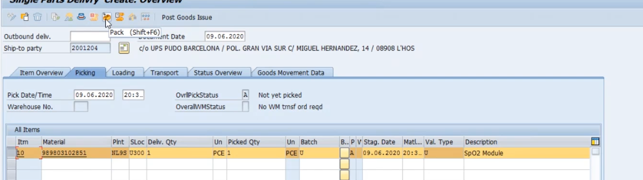

It will nav to another page there , we have give 38 as shown below(make sure 38).

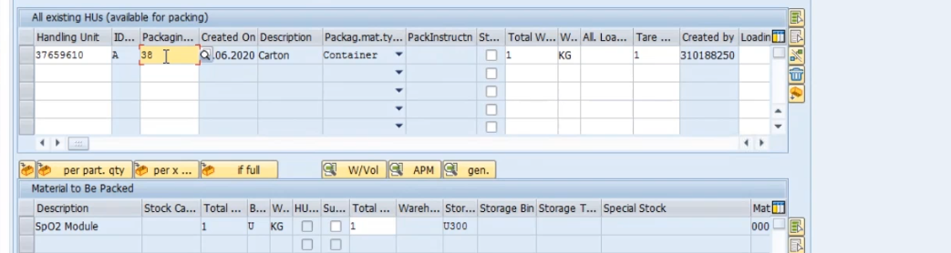

And double click on 38 and it will nav to another page and here

Provide UPS for Identification 2 and click back button.

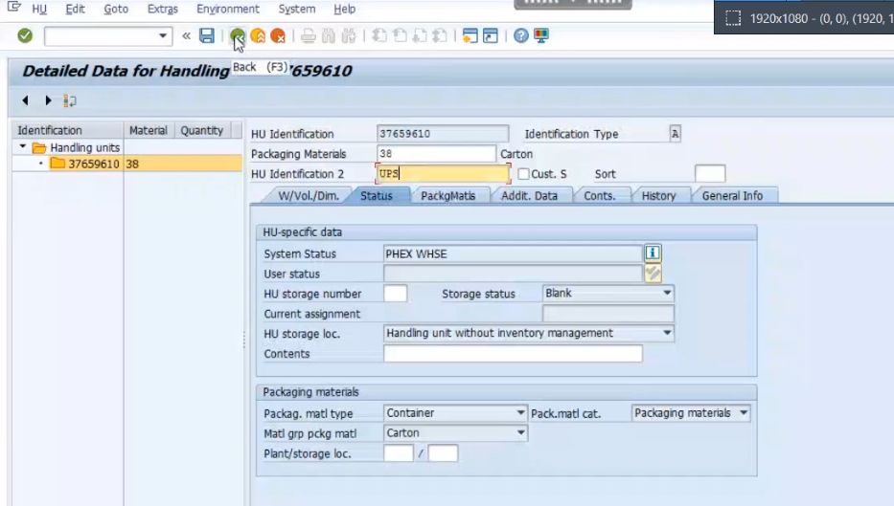

Verify the message as show below



Select the both rows and click pack button as show

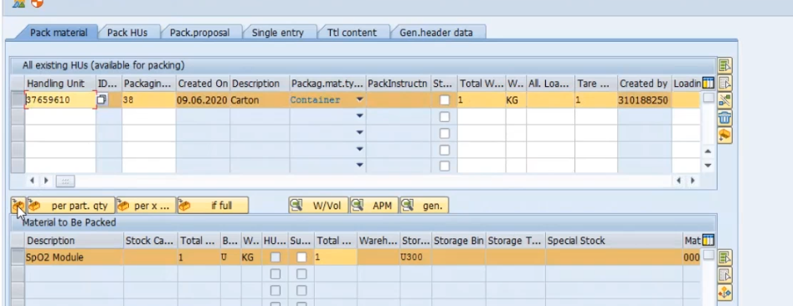

See the message as material was packed

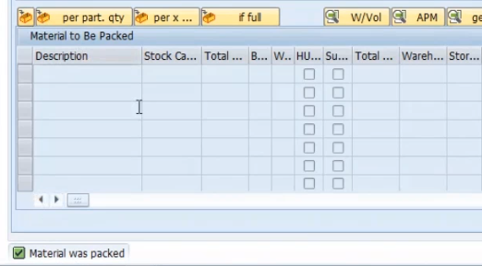

Click on back

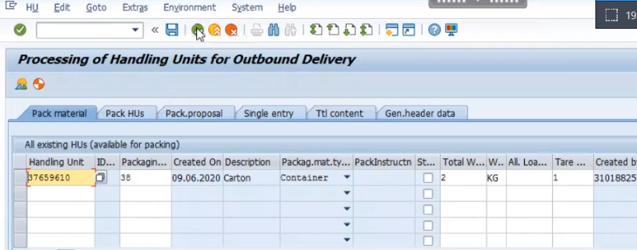

Select the row and click on extra and click on Serial Numbers

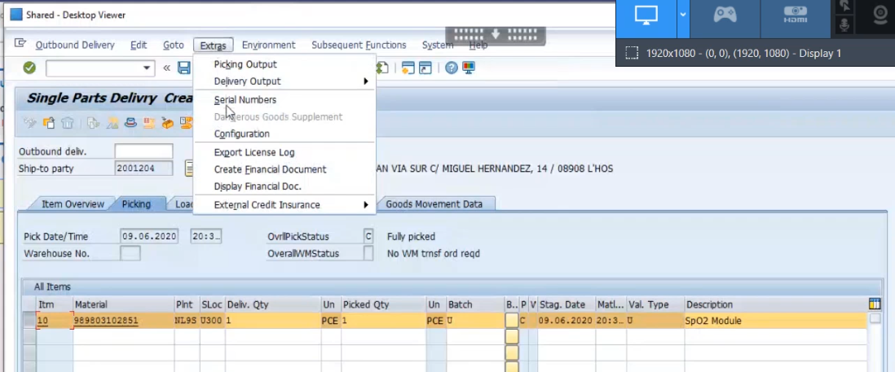

Click on Serial number Automatically

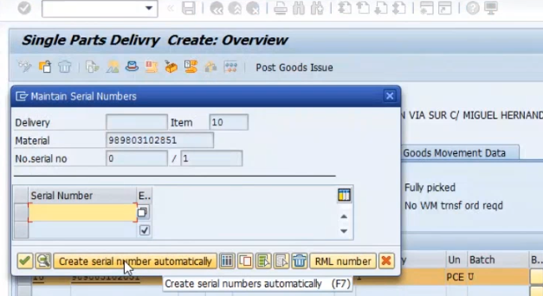

Click on Continue as show below

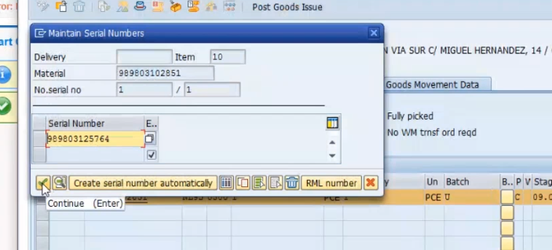

Select the row and save it

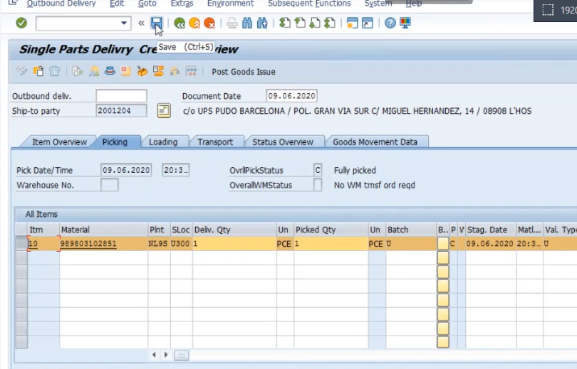

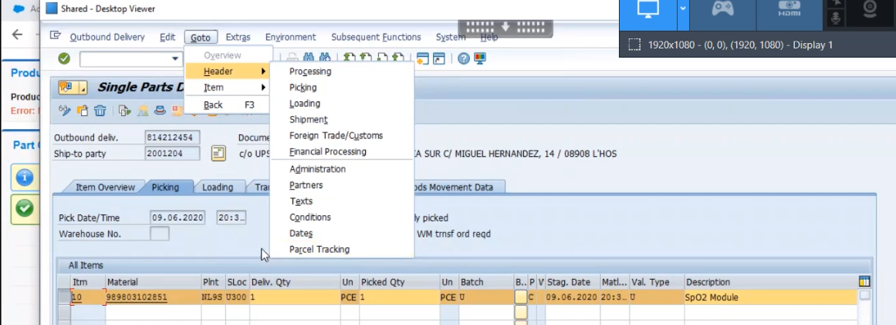

If you are testing PGI & you have do the perform , and it is not mandatory .

Provide the nvl02n and click on enter.

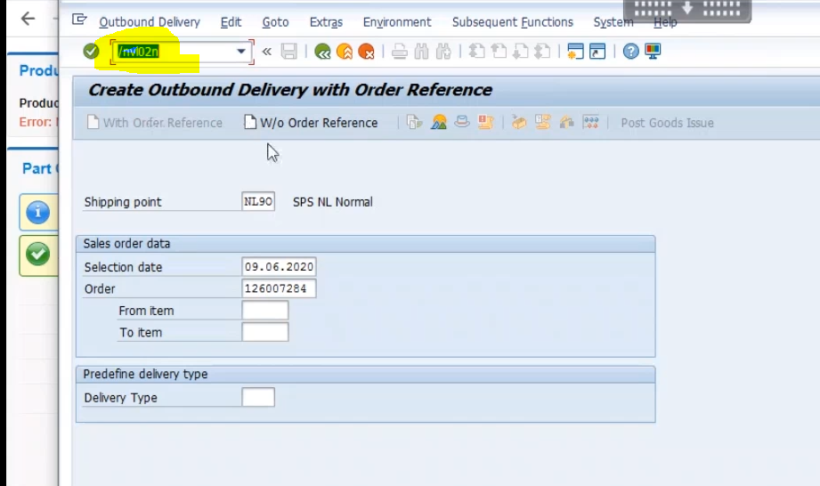

Click on the Post Goods Issue

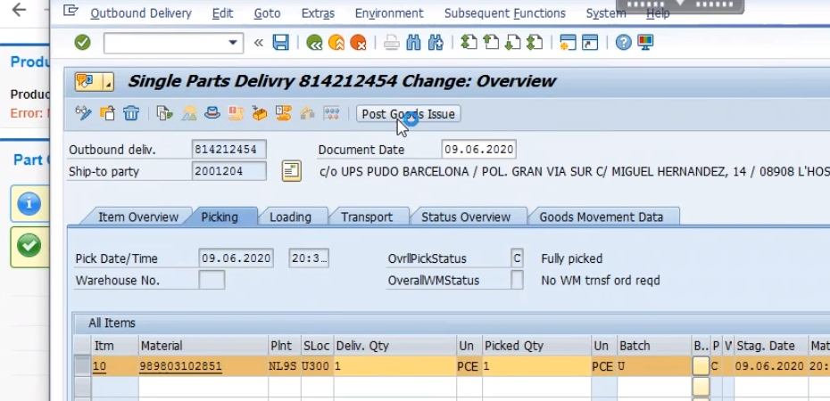

Verify the below message.



Done PGI is complete.